Date | 30/10/2025
Time id | NM2025TMID07740
Project name | Streamlining Ticket Assignment for Efficient Support Operations
Maximum mark | 4 marks

PROJECT DESIGN PHASE 2
Data Flow Diagram (DFD) – Streamlining Ticket Assignment for Efficient Support Operations

Level 0 – Context Diagram
Overview:
This high-level diagram shows how data moves between external entities and the main ticket assignment system.
External Entities:
- Customer/User: Submits new support tickets.
- Support Agent: Receives assigned tickets and updates status.
- Admin/Manager: Monitors performance, workload, and system reports.
Main Process:
- Streamlined Ticket Assignment System – The central process that handles ticket creation, classification, routing, and monitoring.
Data Flows:
- From Customer → System: Ticket details (issue type, priority, description).
- From System → Support Agent: Assigned ticket notifications and workload updates.
- From Support Agent → System: Ticket progress, resolution updates, and status changes.
- From System → Admin: Analytics reports and performance summaries.

Level 1 – Detailed Data Flow Diagram
Process 1: Ticket Creation
- Input: Ticket data (submitted by user).
- Output: Ticket record stored in the database.
- Data Store: Ticket Database.
Process 2: Ticket Classification
- Input: Ticket record from Ticket Database.
- Function: Analyze content using keywords, urgency, and category.
- Output: Ticket category and priority tag.
- Data Store: Ticket Classification Rules.
Process 3: Ticket Assignment
- Input: Classified ticket and Agent Database.
- Function: Match ticket with suitable agent based on skills, workload, and availability.
- Output: Assigned ticket sent to agent.
- Data Store: Agent Profile Database.
Process 4: Ticket Tracking & Update
- Input: Agent updates ticket status (in-progress, resolved).
- Output: Updated records and progress tracking.
- Data Store: Ticket Tracking Log.
Process 5: Reporting & Analytics
- Input: Ticket and agent performance data.
- Function: Generate insights for workload, resolution time, and performance efficiency.
- Output: Dashboards and reports
- for Admin.
- Data Store: Analytics Database.

Data Stores
- Ticket Database: Stores all created tickets.
- Agent Profile Database: Stores agent details, skills, and workload.
- Ticket Classification Rules: Contains predefined keywords, rules, and AI models for classification.
- Ticket Tracking Log: Tracks ticket progress and updates.
- Analytics Database: Stores performance and efficiency data for reporting.

Key Data Flows
- Customer → System: Ticket details.
- System → Agent: Assigned ticket and alerts.
- Agent → System: Ticket updates and resolution info.
- System → Admin: Performance analytics and reports.

EXAMPLE
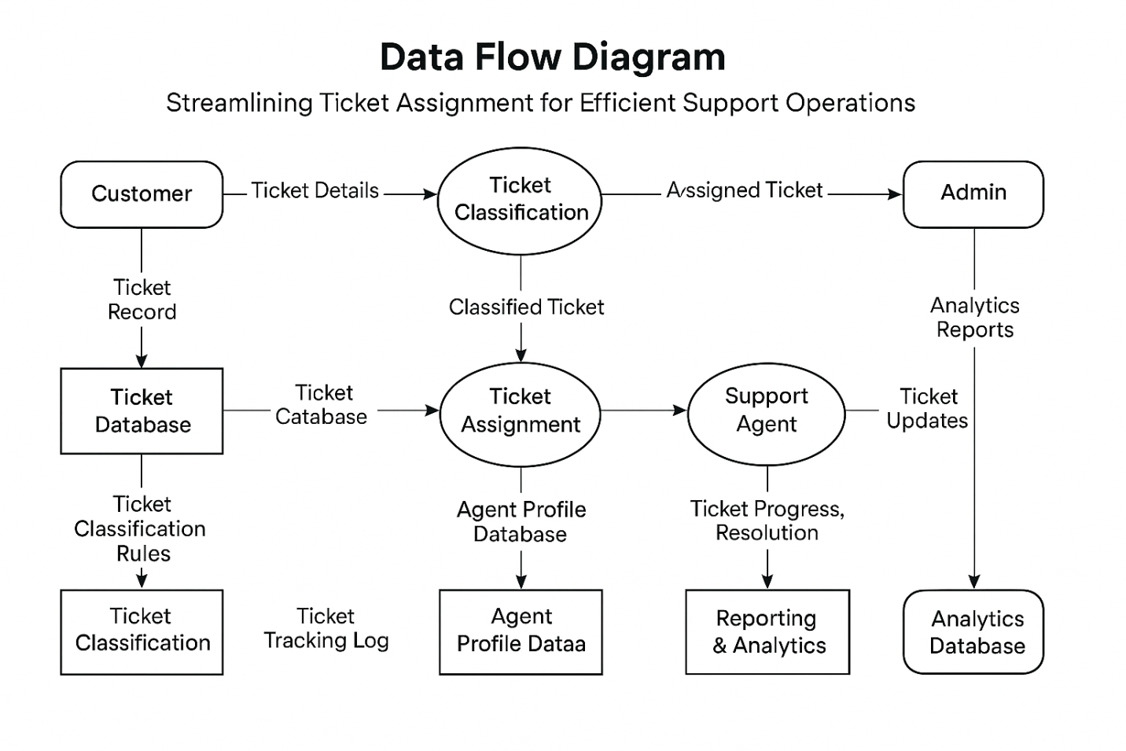

User Stories
1. Support Agent
- As a support agent, I want tickets to be automatically assigned based on my skills and workload, so that I can focus on resolving issues efficiently without spending time on manual ticket selection.
2. Support Manager
- As a support manager, I want to monitor ticket distribution and agent performance in real time, so that I can ensure fair workload balance and improve overall team productivity.
3. End User (Customer)
- As a customer, I want my support tickets to be assigned to the right agent quickly, so that my issue gets resolved faster and communication is more effective.
4. System Administrator
- As a system administrator, I want to configure and maintain the ticket assignment rules and algorithms, so that the system remains flexible, accurate, and aligned with evolving business needs.
5. Quality Assurance Analyst
- As a QA analyst, I want to analyze ticket resolution trends and feedback, so that I can identify recurring issues and recommend improvements for system reliability.
